**Race Conditions**

A situation where several processes access and manipulate the same data concurrently, and the outcome of the execution depends on the particular order in which the access takes place, is called race condition.

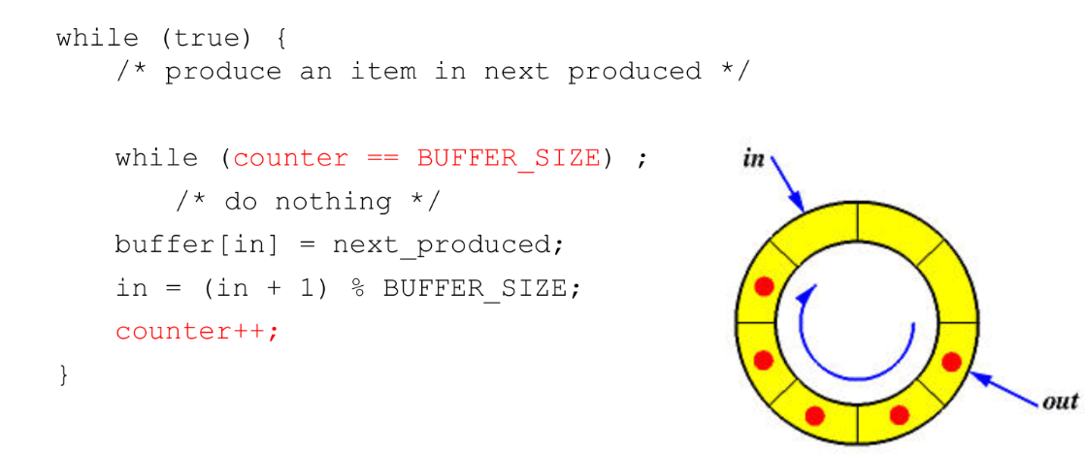

An integer **counter** that keeps track of the number of full buffers. Initially, counter is set to 0. It is incremented by the producer after it produces a new buffer and is decremented by the consumer after it consumes a buffer.

This requires **synchronization** to prevent **race conditions** as both processes are sharing the same variable.

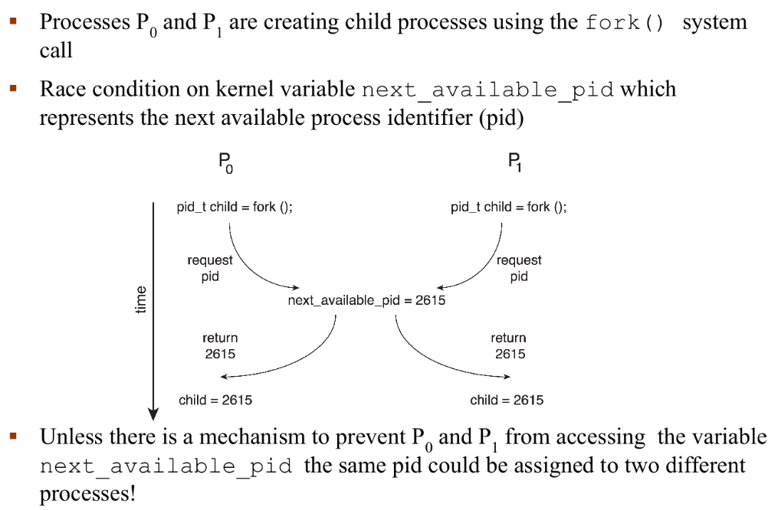

**Critical Section: Concurrency In Operating Systems**

The **critical section** is a part of a program where shared resources or data are accessed by various processes. When multiple processes or threads are executing simultaneously, their access to these shared resources must be coordinated to avoid inconsistencies or corruption.

**Critical Section Problem**

The **critical section problem** arises when multiple processes try to execute their critical sections at the same time, leading to conflicts or undesirable behavior. The problem is to design a protocol that ensures safe access to the shared resources while maintaining the integrity of the data.

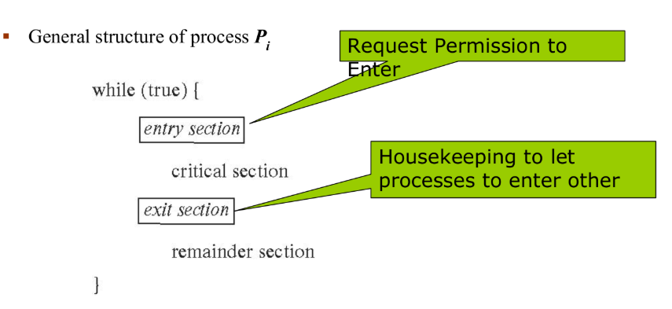

1. **Entry Section**

The entry section is where a process requests permission to enter its **critical section**. This is the phase where synchronization mechanisms (like locks, semaphores, or monitors) are applied to ensure that only one process at a time can access shared resources. This helps prevent race conditions or conflicts.

2. **Critical Section**

The critical section is the part of the process where shared resources are accessed or modified. This section is protected by entry sectionx to ensure that no other process can execute its critical section simultaneously, maintaining data integrity.

3. **Exit Section**

After a process finishes executing its critical section, it enters the exit section. This is where housekeeping tasks are performed to allow other processes to enter their critical sections. For instance, releasing locks or signalling other processes happens in this phase.

4. **Remainder Section**

The remainder section is where the process performs operations that don’t require access to shared resources. This section can be executed concurrently with other processes without synchronization.

**Requirements for Solving the Critical Section Problem**

To solve the problem, any protocol or mechanism must satisfy these conditions:

* **Mutual Exclusion**: Only one process can be in its critical section at a time.
* **Progress**: If no process is executing in its critical section and there exist some processes that wish to enter their critical section, the decision about who goes in next shouldn’t be delayed forever.
* **Bounded Waiting**: Each process waiting to enter the critical section should have a bounded number of attempts or time to wait.
  + There must be a **limit** to how many times **other processes can enter their critical sections before P1 is allowed to enter**.
  + **P1 shouldn't be kept waiting forever while others keep going in**.
  + There should be a **maximum number of turns others can take before it gets P1's turn**.
  + **Example:** Multiple programs (kernel processes) accessing a list of all open files in your system (shared resource).
  + If there’s no Bounded Waiting:
  + One or two processes might **keep accessing it again and again,**
  + While others wait and wait, possibly forever.
  + This creates a **race condition** and **unfairness**.

**Critical-Section Handling in Operating Systems (OS)**

Critical-section handling in an OS is crucial for managing concurrent processes, particularly when they access shared resources. The way it is handled depends on whether the kernel is **preemptive** or **non-preemptive**.

**Preemptive Kernel**

**• Definition:**

• A preemptive kernel allows the OS to interrupt a process running in kernel mode in favor of a higher-priority task.

**• Preemption:**

• The OS can suspend the currently scheduled task to let a higher-priority task execute.

• This technique is part of the system's preemptive scheduler, which is responsible for interrupting and later resuming tasks.

• Preemption is applicable only to processes running in kernel mode.

•**Advantages:**

• More responsive to user inputs, ensuring quicker execution of high-priority tasks.

• Suitable for real-time systems where responsiveness is critical.

**• Challenges:**

• Shared kernel data may be vulnerable to race conditions. For example, two processes might simultaneously try to update shared kernel variables, leading to inconsistencies.

•A preemptive kernel needs to be carefully designed to avoid such problems, typically by using synchronization mechanisms like spinlocks, semaphores, or mutex locks.

**Non-Preemptive Kernel**

• **Definition:** In a non-preemptive kernel, a process runs uninterrupted in kernel mode until it:

1. Exits kernel mode,

2. Blocks (e.g., waiting for 1/0), or

3. Voluntarily yields the CPU.

**• Advantages:**

• Essentially free of race conditions in kernel mode, since only one process is active in the kernel at a time.

• Simplifies the design of the kernel, as synchronization mechanisms are less critical.

• **Disadvantages:**

• May be less responsive to user input, as a lower-priority process in kernel mode cannot be interrupted to run a higher-priority task.

• Less suitable for real-time systems where quick task switching is required.

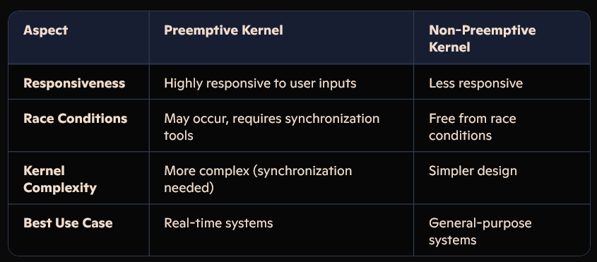

**Peterson’s Solution/Two Process Solution/Humble Algorithm**

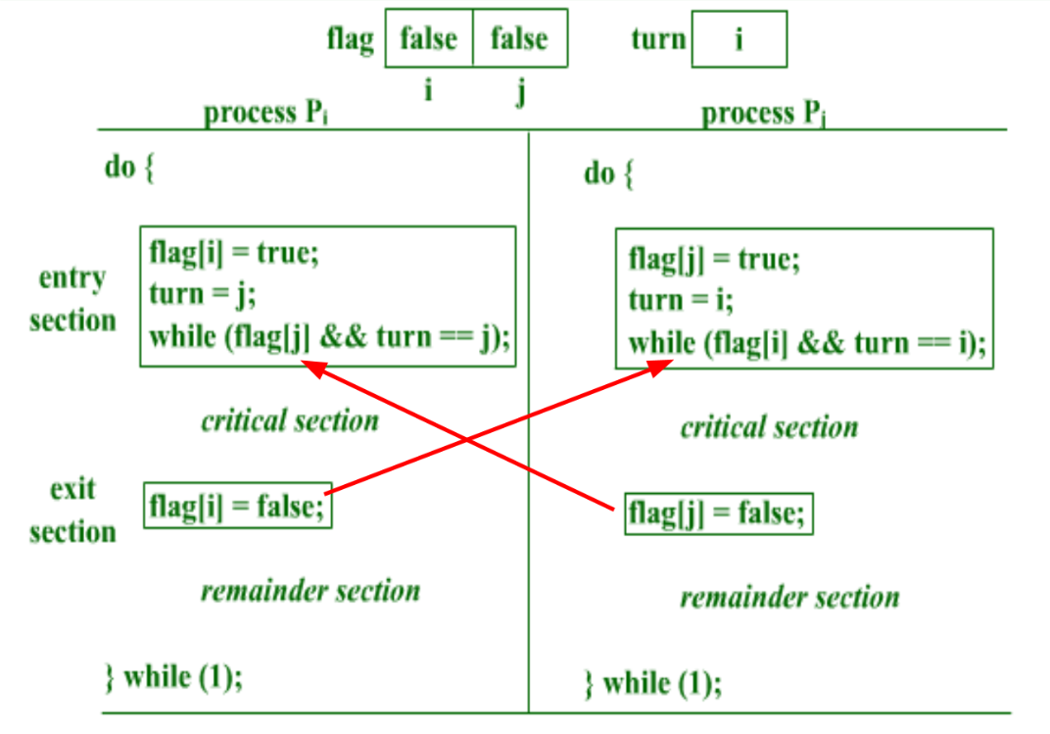

**1. Mutual Exclusion:**

* **Preserved:** Yes. Peterson's solution guarantees that at most one process can be inside the critical section at any time.
* Pi enters critical section only if turn == i, turn cannot be both i and j at the same time.

**2. Progress Requirement:**

* **Satisfied:** Yes. If no process is in its critical section and some processes wish to enter, only those processes that are not in their remainder section can participate in deciding which will enter its critical section next, and this decision cannot be postponed indefinitely.
* **Reasoning:** If one process wants to enter (flag[i] = true) and the other doesn't (flag[j] = false), the waiting process will not stay in the while loop and will enter the critical section. If both processes want to enter, the turn variable ensures that one of them will eventually enter. The process whose turn it is not (turn == j for process i) will enter the critical section (assuming the other process eventually exits). The decision of who enters is made within a finite time.

**3. Bounded-Waiting Requirement:**

* **Not strictly guaranteed in all theoretical scenarios, but practically very difficult to violate.**
* **Reasoning:** The bounded-waiting requirement states that there exists a bound on the number of times that other processes are allowed to enter their critical sections after a process has made a request to enter its critical section and before that request is granted.
* **Theoretically:** While Peterson's solution prevents deadlock and ensures progress, a determined process could theoretically keep setting its flag to true and turn to the other process indefinitely, potentially delaying the other process. However, this would require a very specific and unlikely sequence of events where one process continuously expresses interest and yields the turn *just* as the other is about to enter.

**Mutex**

**Mutex** stands for **Mutual Exclusion**. It is a **lock** that allows **only one thread/process** to **access a critical section** at a time. It prevents **race conditions** when multiple threads are modifying **shared data** at the same time.

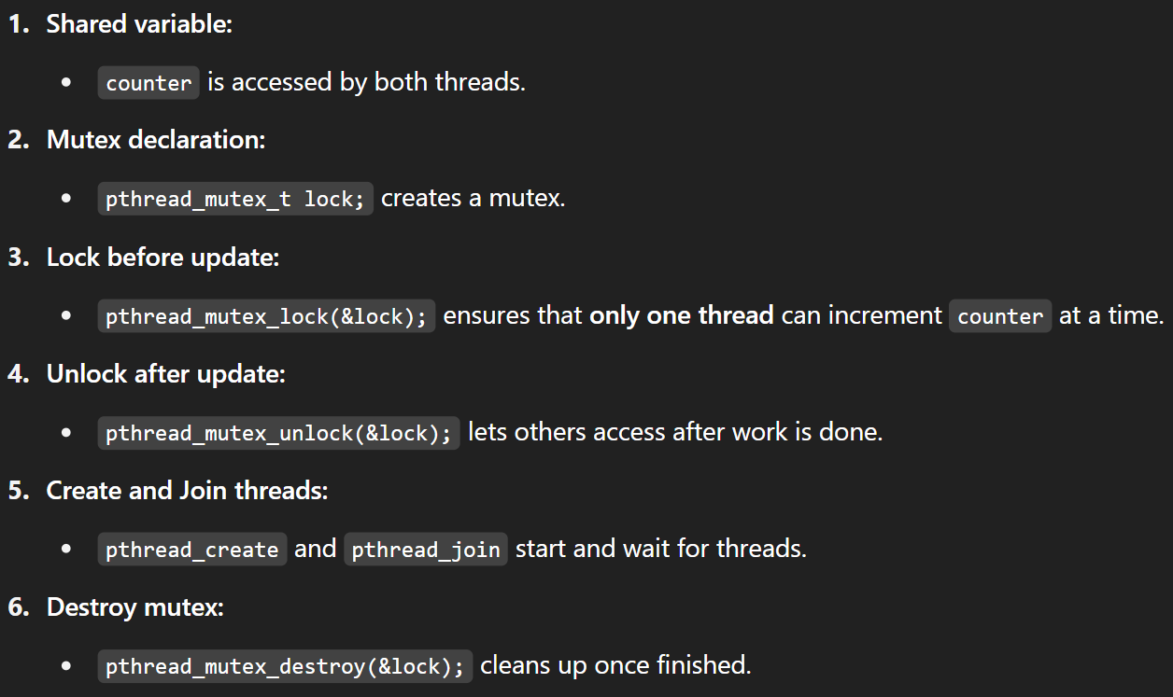



**Semaphore**

A semaphore maintains a count. This count represents the number of available resources, or the number of signals received. Semaphores are used to control access to shared resources and to synchronize the actions of multiple processes or threads. They help in preventing race conditions and ensuring orderly execution in concurrent environments.

* It's an integer variable that is accessed only through two atomic operations: wait (or P) and signal (or V). They are great when **multiple instances** of a resource are available.
* They can **control access to multiple resources** (for example, 5 printers).

**Types of Semaphores:**

* **Binary Semaphore (Mutex):**
  + The counter can only have two values: 0 and 1.
  + It's primarily used to implement mutual exclusion, acting like a lock. A value of 1 typically means the resource is available, and 0 means it's being used.
* **Counting Semaphore:**
  + The counter can have any non-negative integer value.
  + It's used to control access to a limited number of identical resources. The initial value of the counter determines the maximum number of processes/threads that can access the resource concurrently.

**Include Header:**



**Declare a Semaphore:**



**Initialize a Semaphore:**



**Wait Operation:**



**Signal Operation:**



**Get Semaphore Value:**



**Destroy a Semaphore:**



**Producer-Consumer Problem Solved Using mutex and semaphores**

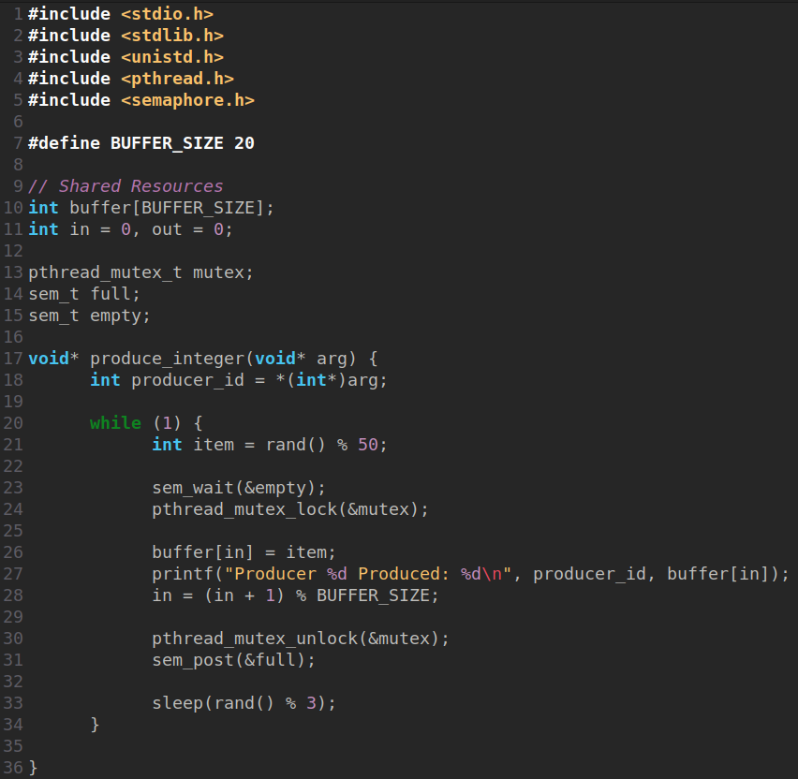

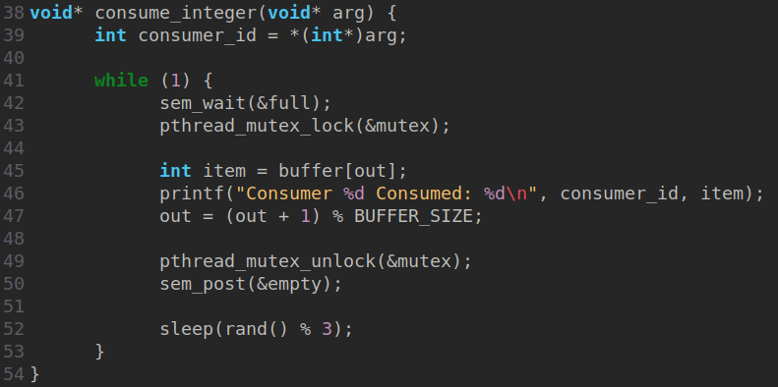

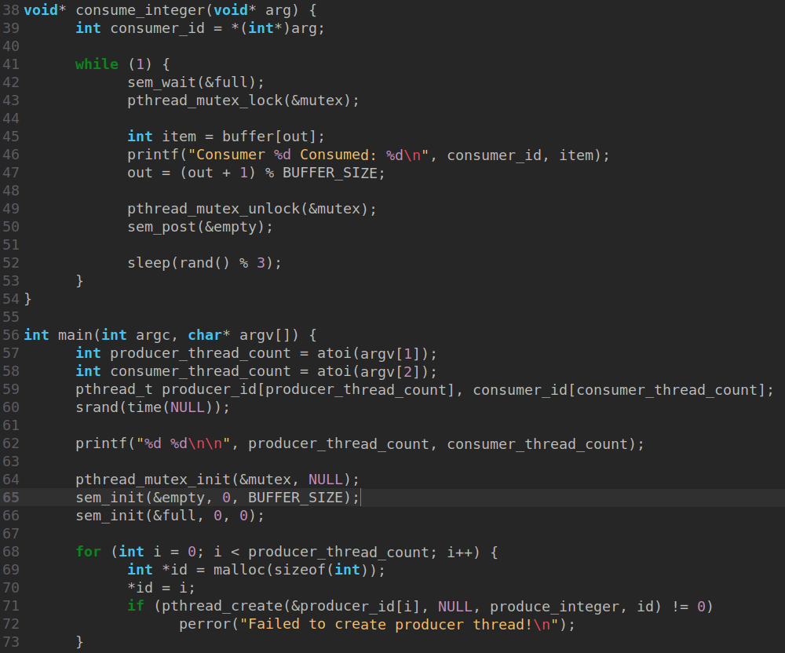

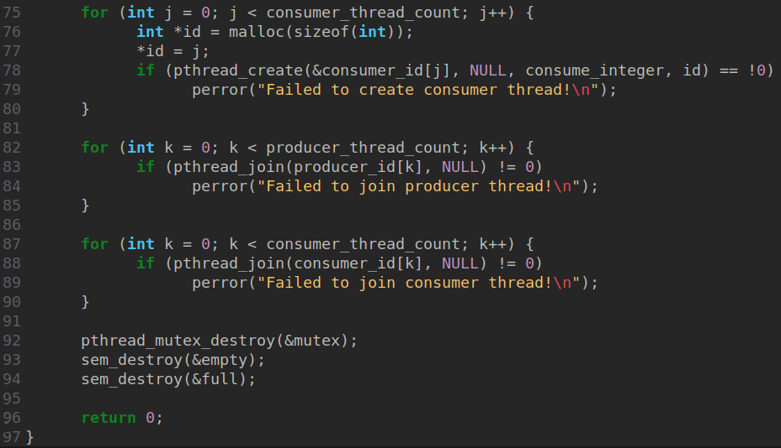

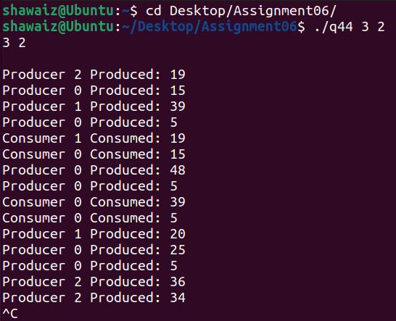

**Peterson’s Solution Example**

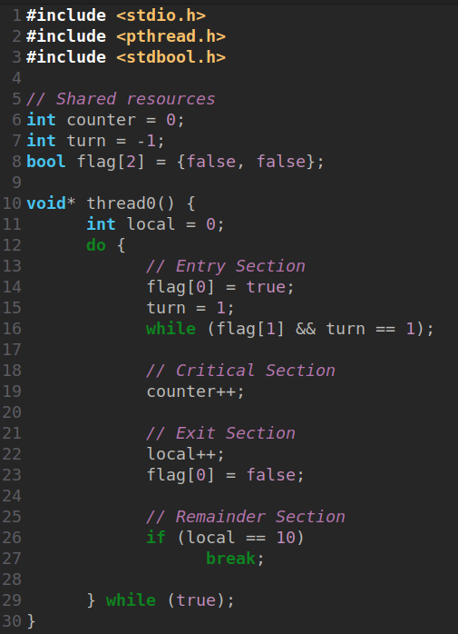

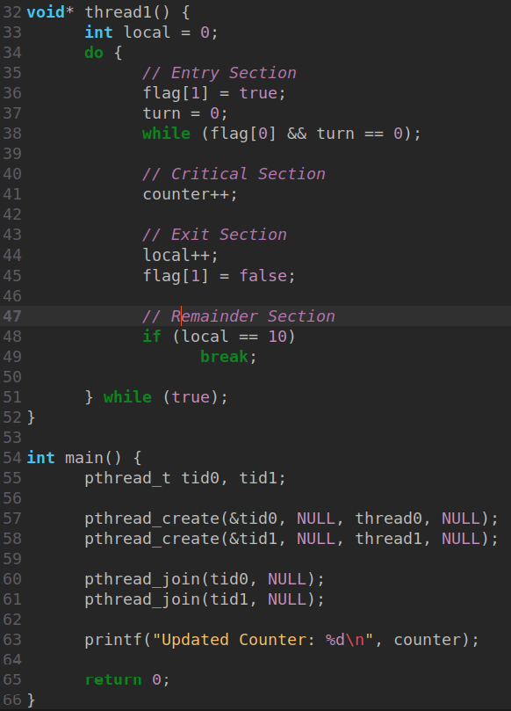

**Question: Is it possible for a system to experience starvation without having deadlock? Provide an example of how starvation might occur in a multithreaded environment without leading to deadlock.**

Yes, it is possible for a system to experience **starvation** without leading to **deadlock**. Starvation occurs when a thread or process waits indefinitely to gain access to a shared resource because higher-priority threads or processes continuously occupy it, preventing the starving thread from making progress. Deadlock, on the other hand, involves a circular waiting scenario where processes block each other indefinitely, unable to proceed.

Example of Starvation in a Multithreaded Environment:

Imagine a scenario where a **multithreaded program** uses a priority-based scheduling mechanism:

1. **Setup**:
   * A shared resource (e.g., a database) is protected by a mutex lock.
   * Threads are assigned priorities: higher-priority threads are scheduled before lower-priority ones.
2. **Scenario**:
   * Several **high-priority threads** frequently acquire the lock to perform their tasks.
   * A **low-priority thread** repeatedly tries to access the shared resource but is delayed each time because the scheduler prefers the higher-priority threads.
   * Even though the resource is technically available (no deadlock), the low-priority thread might never get its turn if high-priority threads keep preempting it.
3. **Outcome**:
   * The low-priority thread faces **starvation** as it waits indefinitely, but since no circular dependency exists, the system does not experience **deadlock**.

**Question: Imagine you are designing a banking application that allows multiple users to perform transactions simultaneously. To ensure data consistency, you must implement proper synchronization mechanisms. Below are some critical sections and tasks that require synchronization.**

Scenario:

• There are several users, each performing transactions on a shared bank account.

• The bank account has a balance which can be accessed and modified by multiple users simultaneously.

• A user can either deposit or withdraw from the account. If two users attempt to withdraw more money than the available balance at the same time, a race condition could occur.

Answer the following questions:

**1. What would happen if there’s no synchronization between deposit and withdraw operations? Explain the potential race condition in this context.**

Without proper synchronization between deposit and withdraw operations in the banking application, **data inconsistency and incorrect account balances** would occur. This is due to the potential for **race conditions**.

**Race Condition Example**

Let’s assume:

* The initial account balance is **$100**.
* **User A** wants to withdraw **$80**.
* **User B** wants to withdraw **$50**.

Here’s how the race condition unfolds in the absence of synchronization:

1. **Thread A (User A)** reads the balance:
   * if (balance >= 80) → True, since the balance is $100.
2. **Thread B (User B)** reads the balance:
   * if (balance >= 50) → True, since the balance is still perceived as $100.
3. **Thread A** deducts $80:
   * balance = balance - 80 → Remaining balance is **$20**.
4. **Thread B** deducts $50:
   * balance = balance - 50 → Remaining balance becomes **$-30**, which is invalid (insufficient funds should have prevented the withdrawal).

This kind of incorrect balance occurs because both threads read the same initial value before either of them updates it.

**Potential Problems**

* **Overdrawn Account**: The account ends up being overdrawn because two users were allowed to withdraw more than the actual available balance.
* **Inconsistent Results**: The account balance is no longer accurate, violating the integrity of the data.
* **Lost Deposits:** If a deposit and a withdrawal happen concurrently, the deposit might not be correctly reflected in the final balance.
* **Incorrect Balances:** The account balance could become completely inaccurate, leading to financial discrepancies.

**2. How would you modify the program to prevent multiple processes from accessing the account balance at the same time using a mutex lock?**

**Mutex lock** to ensure mutual exclusion. A mutex allows only one process to access a critical section at a time, protecting shared resources like the account balance from race conditions.

**Explanation**

1. **Critical Section**:
   * The deposit and withdrawal operations are wrapped with pthread_mutex_lock() and pthread_mutex_unlock(). This prevents simultaneous access to the shared variable account_balance.
2. **Thread Safety**:
   * Only one thread can modify the account_balance at a time, eliminating race conditions.

**3. If you were to use a semaphore instead of a mutex, how would it change the behavior of the synchronization? What are the potential downsides of using semaphores for this case?**

How Using a Semaphore Changes Behavior

1. **Semaphore Basics**:
   * A semaphore is essentially a counter that regulates access to shared resources. It allows multiple threads (up to a specified number) to enter a critical section simultaneously if the counter value is greater than zero.
   * Unlike a mutex, which is strictly binary (locked or unlocked), a semaphore can allow more than one thread into the critical section.
2. **Behavior with a Semaphore**:
   * In this case, you would initialize a semaphore with a value of **1** to mimic the behavior of a mutex (binary semaphore).
   * When a thread accesses the critical section (e.g., to deposit or withdraw), it decreases the semaphore counter using sem_wait(). After completing its task, it increases the counter using sem_post().
   * Synchronization behavior would resemble a mutex since the semaphore restricts access to one thread at a time for a binary semaphore.
3. **Key Difference**:
   * A mutex is ownership-based, meaning the thread that locks it must also unlock it. In contrast, semaphores are not ownership-based, so any thread can signal (sem_post()) to increase the semaphore's counter, even if it did not acquire (sem_wait()) it. This flexibility can lead to unintended behavior if not used carefully.

**Potential Downsides of Using a Semaphore**

1. **No Ownership**:
   * Since semaphores do not enforce ownership, a bug or poorly managed logic can cause a thread to signal (sem_post()) the semaphore incorrectly, potentially allowing multiple threads into the critical section when only one should be allowed.
2. **Risk of Deadlock or Resource Leaks**:
   * If a thread crashes or fails to release the semaphore (i.e., doesn't call sem_post()), other threads will be blocked indefinitely, causing a deadlock-like scenario. Mutexes avoid this issue by ensuring that only the thread that locks it can unlock it.
3. **Overhead**:
   * Semaphores, especially counting semaphores, have slightly higher overhead than mutexes because they maintain a counter and allow more complex behaviors (like allowing multiple threads to access a resource simultaneously).
4. **Misuse in Binary Mode**:
   * Using a semaphore as a binary semaphore (initial value = 1) to replicate mutex-like behavior adds unnecessary complexity because mutexes are simpler and purpose-built for this exact scenario.
5. **Complexity in Understanding**:
   * In a system where only a single thread should access the resource at a time (e.g., the bank account balance), using a semaphore may confuse maintainers or developers, as mutexes are semantically clearer for this use case.

**When to Use a Semaphore Instead of a Mutex**

Semaphores are better suited for scenarios where:

* **Multiple threads** are allowed simultaneous access to a resource (e.g., a pool of database connections, limited by the semaphore's initial value).
* **Non-blocking synchronization** is needed, as semaphores can allow signaling between threads in a more flexible way.

**4. Would Peterson's solution be suitable for solving the race condition in this case? Why or why not?**

**Peterson's Solution**

Peterson's solution is a software-based algorithm used for achieving mutual exclusion between two threads (or processes). It guarantees thread-safe access to shared resources without requiring hardware-level synchronization primitives, such as mutex locks. It relies on two shared variables:

1. **Flag Array**: Indicates whether a thread wants to enter its critical section.
2. **Turn Variable**: Determines which thread has priority to enter its critical section.

**How Peterson's Solution Works:**

1. When a thread wants to access the critical section, it sets its flag to true and gives priority to the other thread via the turn variable.
2. It then waits until the other thread's flag is false or it is its turn to enter the critical section.
3. This ensures mutual exclusion.

**Why It Is Not Suitable in This Case**

1. **Only Supports Two Threads**:
   * Peterson's solution was designed for synchronization between **two threads**. In the banking application, there are **multiple users**, and each user could have multiple threads performing deposits and withdrawals. Peterson's solution does not scale to support more than two threads without significant modifications.
2. **High CPU Usage**:
   * Peterson's solution relies on **busy waiting** to check the flags and turn variable. This results in inefficient use of CPU resources since the threads waste cycles repeatedly checking the conditions instead of being blocked until the resource is available.

**5. In the case of the banking system, is it acceptable for a process to busy-wait while waiting to access the critical section? Why or why not?**

No, it is generally **not acceptable** for a process to busy-wait while waiting to access the critical section in the case of a banking system. Busy-waiting is inefficient and can lead to significant performance and scalability issues, especially in a system with high concurrency.

**Why Busy-Waiting is Problematic**

1. **Wastes CPU Resources**:
   * Busy-waiting involves a process continuously checking a condition (e.g., whether the critical section is available) instead of performing meaningful work or relinquishing the CPU.
   * In a banking system, where multiple users perform transactions simultaneously, busy-waiting could monopolize CPU cycles and degrade performance for other critical operations.

**6. How would deadlock arise in a banking application that improperly implements synchronization? Provide a specific example.**

Deadlock in a banking application can occur when multiple threads or processes block each other indefinitely due to improper synchronization of shared resources. Deadlock typically arises when the following conditions are met simultaneously:

1. **Mutual Exclusion**: At least one shared resource (e.g., the account balance) is held exclusively by one thread.
2. **Hold and Wait**: A thread holding one resource waits for another resource that is held by a different thread.
3. **No Preemption**: Resources cannot be forcibly taken from threads holding them.
4. **Circular Wait**: Threads form a cycle where each thread is waiting for a resource held by the next thread in the cycle.

**Specific Example in a Banking Application**

Imagine the following scenario:

1. **Shared Resources**:
   * Resource A: A mutex lock for the bank account balance.
   * Resource B: A mutex lock for a transaction history log.
2. **Thread 1** (Depositor):
   * Locks **Resource A** to update the account balance.
   * Then tries to lock **Resource B** to record the transaction in the history log.
3. **Thread 2** (Withdrawer):
   * Locks **Resource B** to record the withdrawal in the transaction history.
   * Then tries to lock **Resource A** to update the account balance.

**How Deadlock Occurs**

1. **Thread 1** locks **Resource A** and begins updating the account balance. It then blocks while waiting to acquire **Resource B** (held by Thread 2).
2. **Thread 2** locks **Resource B** and begins recording the withdrawal in the transaction history. It then blocks while waiting to acquire **Resource A** (held by Thread 1).
3. Both threads are now waiting indefinitely for each other to release their respective locks. Neither can proceed, and the system is in deadlock.

**7. What synchronization technique could you use if you want to allow concurrent deposits but serialize withdrawals? Explain how this could be achieved.**

* **Deposits** only add to the balance and do not require exclusive access.
* **Withdrawals** must be serialized to prevent race conditions and ensure funds are available.

**Serialized Withdrawals**:

* For withdrawals, use the mutex to ensure only one thread modifies the balance at a time.

**Concurrent Deposits**:

* Allow deposits without holding the mutex. This ensures that multiple threads can deposit at the same time. We can also use semaphore to easily allow multiple threads to access the shared account balance.

**8. If you use a semaphore to control access to the critical section (deposit/withdraw operations), what would happen if the semaphore count is set to 1 versus a higher number?**

**Semaphore Count = 1 (Binary Semaphore)**

1. **Behavior**:
   * The semaphore acts as a **mutex**, allowing only one thread/process to enter the critical section at a time.
   * Deposit and withdrawal operations would be serialized, meaning only one thread can perform its operation on the account balance at any given time.
2. **Impact on Banking Application**:
   * **Serialization**: Both deposits and withdrawals are strictly serialized, ensuring complete safety against race conditions.
   * **Throughput Reduction**: Concurrent deposits (which don’t necessarily need exclusive access) are also serialized, potentially reducing efficiency.
   * **Data Integrity**: Strong mutual exclusion guarantees consistency in account balance updates, but overall performance may suffer due to unnecessary serialization of deposits.
3. **Use Case**:
   * Suitable when both deposits and withdrawals involve complex operations that must be synchronized to avoid contention over shared resources.

**Semaphore Count > 1**

1. **Behavior**:
   * The semaphore allows **multiple threads** to access the critical section concurrently, up to the value of the semaphore count. For example:
     + If the semaphore count is set to 2, **two threads** can perform deposit/withdrawal operations simultaneously.
     + If the count is set to a higher number, more threads can enter the critical section concurrently.
2. **Impact on Banking Application**:
   * **Concurrent Deposits**: Multiple deposit operations can occur at the same time, improving throughput and efficiency. This is particularly beneficial for high-frequency deposit transactions.
   * **Serialized Withdrawals**: If withdrawals are included in the same semaphore logic, multiple withdrawal threads might access the account balance simultaneously, potentially leading to race conditions unless additional controls are implemented (e.g., a separate withdrawal lock).
   * **Risk of Data Corruption**: The higher semaphore count increases the risk of data inconsistency due to simultaneous withdrawals or combined deposit/withdrawal operations that access the same shared resource.
3. **Use Case**:
   * Suitable for scenarios where **deposits are frequent and do not require strict serialization**, but additional safeguards (e.g., separate locks) are implemented for serialized withdrawals.

**Recommendation for Banking Application**

1. **Separate Semaphores**:
   * Use **one semaphore** (count > 1) for deposits to allow concurrency.
   * Use a **binary semaphore** (count = 1) or mutex for withdrawals to ensure serialization.
   * This balances efficiency and data consistency.

**9. If the system experiences high transaction volume, how would you optimize synchronization to avoid performance bottlenecks, considering factors like context switching and lock contention?**

**1. Reduce Lock Contention**

Lock contention occurs when multiple threads attempt to acquire the same lock, leading to delays. Here's how to minimize it:

* **Use Fine-Grained Locks**:
  + Divide shared resources into smaller, independent units, and protect each with its own lock (e.g., separate locks for each user account or transaction type). This reduces contention by localizing the scope of locks.
* **Sharded Data Structures**:
  + Partition the account balance database into shards, where each shard is managed by a separate lock. Threads operating on different shards can proceed in parallel.
* **Prefer Read-Write Locks**:
  + Use **read-write locks** for operations where reads (e.g., querying account balances) are more frequent than writes (e.g., deposits/withdrawals). Multiple readers can access shared data concurrently, while writers still get exclusive access.

**2. Reduce Context Switching**

Frequent context switching between threads can degrade performance in high-volume systems. Optimize for fewer context switches:

* **Thread Affinity**:
  + Pin threads to specific CPU cores to avoid unnecessary switching between processors.
* **Use Lock-Free Data Structures**:
  + Where possible, use lock-free or wait-free algorithms (e.g., atomic operations) for read-heavy workloads. These minimize thread blocking and reduce the need for context switching.
* **Batch Transactions**:
  + Group multiple transactions together and process them in a single lock acquisition. For example:
    - Instead of acquiring the lock for every deposit, batch multiple deposits and update the balance once.